**Course: Introduction to Data Science (DS2006) - Laboratory 08**

**Student: Philip Haglund**

**Task 1**: Create a file named [dog.py](http://dog.py) and implement the code shown in Figure 1. What is the output of this code when you run it?

#Define a class for Dogs:

class Dog:

#Defines the attributes (properties dogs have) and initializes them:

#(Attributes are variables that belong to a given class)

def __init__(self, name, age, breed):

self.name = name

self.age = age

self.breed = breed

#Method example:

def bark(self):

print(f"{self.name} looks at you and barks: Woof Woof!")

#Create an object from Class Dog:

dog1 = Dog("Bidu", 1, "Mixed")

#Create another object from Class Dog:

dog2 = Dog("Pipoca", 5, "German Sheperd")

**Figure 1. Code Snippet**

**There is no output as you’re not printing anything to the console. You have a method for printing yet it isn’t called in either of the objects.**

**Task 2**: Considering the current code we have in [dog.py](http://dog.py), what is the output of:

a) print([dog1.name](http://dog1.name))

Bidu

b) print([dog2.name](http://dog2.name))

Pipoca

c) print([dog3.name](http://dog2.name))

ERROR: dog3 is not defined

**Task 3**: Create a new object of the class of Dog in a variable named dog3. Feel free to choose the name, age and breed of this new dog object.



**Task 4**: Replace the method shown in Figure 2 with the method shown in Figure 3. What happens when you try to run the code?

#Method example:

def bark(self):

print(f"{self.name} looks at you and barks: Woof Woof!")

**Figure 2. Code Snippet**

#Method example:

def bark():

print(f"{self.name} looks at you and barks: Woof Woof!")

**Figure 3. Code Snippet**

The bark method is still not called and python has no issue compiling the code. If I were to do dog3.bark() it would give the following error while compiling;

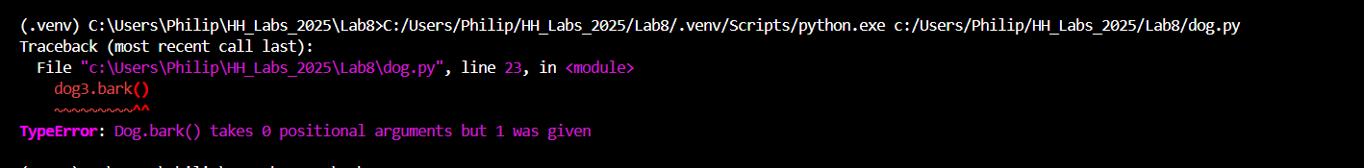

This is because python always passes self for methods automatically but we have no argument for it in the method.

**Task 5**: Replace the method shown in Figure 3 with the method shown in Figure 4. What happens when you try to run the code?

#Method example:

def bark(self):

print(f"{name} looks at you and barks: Woof Woof!")

**Figure 4. Code Snippet**

**You have still not instructed me to call the bark() method on any of the dogs. Since the method isn’t called the code compiles and runs perfectly. If I were to call bark on my dog3 it will give the error;**

It does not know what name is as its supposed to be passed from self. Self is the object the method is being called on which would have the variable name (self.name).

**Task 6**: What is the output of calling dog1.bark() and print(dog1.bark())? Is the output the same? If not, what's the difference between them?

dog1.bark() throws the error;

And print(dog1.bark()) gives;

If I fix the method (revert it to how it was before task 4&5 and run both again)

name -> self.name

dog1.bark()



print(dog1.bark())



It returned “None” because a method always returns something. It returns “None” if unspecified by the method. It printed the “Bidu looks at you and barks: Woof Woof!” due to our method working as intended.

**Task 7**: Create a new attribute called **address** in [dog.py](http://dog.py) class and Update the necessary parts of the code (Hint: __init__ method and constructor calls).

Added an address argument and then set it in the constructor.

**Task 8**: Create a new function called **sleep** in your [dog.py](http://dog.py) class. It should have no parameters to be used and print a message related to the dog being asleep.



It has an argument but technically no parameters that are used to call it as self is automatically passed.

**Task 9**: Create a new function called **barkAt** in your [dog.py](http://dog.py) class. It should take one parameter to be used to print a message that the dog is barking at the string that was passed as a parameter.



Here’s some proof I tested the method from task 8 & 9.

**Task 10**: Create a new file named [cat.py](http://dog.py). In this file define a cat class. The attributes of this class should be: Name and Breed.

**Task 11**: Create an **__init__** method for the initialization of Cat objects.

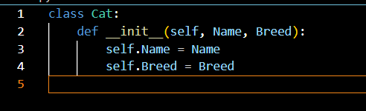

**Task 12**: In the Cat class, create one method that takes no parameters to be used and is related to something that cats do (be creative 🙂)

**Task 13**: In the Cat class, create one method that takes at least one parameter to be used and is related to something that cats do (be even more creative 🙂)

**Task 14**: Using the cat class methods you created, create 5 objects of the class cat and make them use the two different methods you have created. Show the code and output of this process.

Now we want to think about how we could refactor our latest version of the multiplayer Battle of Dices project using object oriented programming.

* **Task 15: Think and reflect individually** what classes do you need to Refactor our latest version of Battle of Dices? Write the classes and their __init__ methods.

The most useful thing you could do is a player class to store things like player wins, rolls, and miscellaneous information. Anything else feels a little overkill for the scope of our game. If we want to widen it more we could classify things like rounds for better data storage or, even make a game class. The game class would make it easy to create a new game if we want to.

* **Task 16: Think and reflect within your group** what classes do you need to Refactor the latest version of Battle of Dices? Write the classes, their __init__ methods and prepare a short presentation for the class. For the presentation please also add the google slides link in this document.

[**https://docs.google.com/presentation/d/1R3KJqzvMf8xvwwxpuajiDBdvsxQuZKDBkumX66E72dQ/edit?usp=sharing**](https://docs.google.com/presentation/d/1R3KJqzvMf8xvwwxpuajiDBdvsxQuZKDBkumX66E72dQ/edit?usp=sharing)